CLASSIC-GOLD E-COMMERCE BUSINESS PERFORMANCE & OPERATIONAL ANALYTICS
An End-to-End Business Intelligence Case Study
Prepared by: Samuel Shobowale, ACA
Tools: Power BI, Power Query, DAX and Excel
Industry: E-commerce / Retail
Reporting Period: 2024/2025
Date: 6th Nov. 2026

1. EXECUTIVE SUMMARY
1.1 Project Background
This project examines the commercial and operational performance of an e-commerce business using an integrated business intelligence approach.
The analysis covers four major business areas: overall business performance, sales performance, marketing effectiveness and inventory management.
The objective is to transform raw business data into meaningful insights that enable management to evaluate performance, identify operational gaps, understand business trends and make informed decisions.
1.2 Project Objectives
The specific objectives of this analysis are to:
- Evaluate overall business performance and revenue trends.
- Identify sales patterns across products, categories, regions and sales channels.
- Assess marketing expenditure and customer acquisition effectiveness.
- Evaluate inventory movement, stock availability and replenishment patterns.
- Provide actionable recommendations for improving business performance.
1.3 Key Findings
Detailed Business Performance Findings – 2025
1. Sales Performance and Revenue Growth
- Revenue growth was primarily volume-driven: Revenue, profit and order volume increased year-on-year despite a relatively stable customer base, indicating increased purchasing frequency among existing customers. However, declining AOV suggests that customers are spending less per transaction.
- Returning customers and key sales channels supported revenue generation: Returning customers contributed 64% of total revenue, while Organic Search, Paid Social, Paid Search and Direct channels were the leading revenue and profit contributors, highlighting the importance of customer loyalty and effective acquisition channels.
- Electronics dominated product category performance: Electronics generated the highest revenue and profit in 2025, making it the leading contributor to overall product performance.
- Q4 recorded the strongest sales performance: The fourth quarter generated the highest revenue and profit, with discounting showing a positive relationship with sales performance, suggesting that promotional activities may have supported increased purchasing activity during the period.
- Lagos remained the leading sales destination: Lagos recorded the highest sales volume by shipping destination, indicating a significant concentration of customer demand in the location.
2. Marketing Performance and Customer Retention
- Advertising engagement improved, but purchase conversion weakened: CTR increased year-on-year, while conversion rate declined. This indicates that although more customers engaged with advertisements, a smaller proportion proceeded to complete purchases.
- Advertising returns improved despite rising acquisition costs: ROAS increased, indicating that advertising-attributed revenue grew faster than advertising expenditure. However, the simultaneous increase in CAC suggests that acquiring customers became more expensive, potentially putting pressure on marketing efficiency.
- Paid Search and Paid Social drove advertising-attributed revenue: These channels accounted for the largest contributions to advertising-attributed revenue, while Organic Search and Direct also remained important sources of overall revenue and profit.
- Q2 recorded the strongest conversion performance: Despite relatively lower CTR, Q2 achieved a higher conversion rate than other quarters, suggesting that customer engagement alone does not determine purchase outcomes and that traffic quality and purchase intent may have played a significant role.
- Existing customers remained central to business revenue: Returning customers generated 64% of total revenue, demonstrating the substantial contribution of repeat purchasing to business performance and the importance of maintaining customer relationships.
3. Inventory Management and Product Returns
- Stock replenishment recorded marginal year-on-year improvement: The replenishment rate increased to 69.65% in 2025, representing a 0.01 percentage-point improvement over 2024. This indicates relatively stable replenishment performance, although the rate alone does not establish whether inventory levels adequately supported demand.
- Product returns increased significantly year-on-year: Returns increased by 28.8% compared with 2024, indicating a higher incidence of returned products and potential weaknesses in product presentation, quality and fulfilment processes.
- Electronics and Fashion recorded the highest return rates: Despite Electronics being the leading revenue and profit-generating category, it also recorded one of the highest return rates. This presents an important distinction between sales performance and post-purchase product performance.
- Product descriptions and fulfilment damage were the major return drivers: Unclear product descriptions and products damaged during fulfilment or delivery accounted for the majority of reported return issues, highlighting gaps in product information accuracy and delivery handling.
Overall Business Performance – Key Findings (2025)
The business recorded positive year-on-year growth in revenue, profit and order volume, despite a relatively stable customer base, indicating increased purchasing activity among existing customers. Returning customers contributed 64% of total revenue, highlighting the importance of customer retention to overall business performance. However, the decline in Average Order Value (AOV) suggests that growth was primarily volume-driven, with customers placing more orders but spending less per transaction.
Marketing performance showed improved advertising engagement and revenue generation, as evidenced by increased Click-Through Rate (CTR) and Return on Advertising Spend (ROAS). Paid Search and Paid Social were the leading contributors to advertising-attributed revenue. However, the simultaneous increase in Customer Acquisition Cost (CAC) and decline in Conversion Rate and AOV indicate that higher advertising engagement and expenditure are not translating proportionately into completed purchases and higher transaction values. This raises concerns about traffic quality, customer conversion and the sustainability of acquisition costs.
Inventory performance recorded a marginal improvement in stock replenishment rate to 69.65%, representing a 0.01 percentage-point increase over 2024. However, product returns increased by 28.8% year-on-year, primarily due to unclear product descriptions and product damage during fulfilment or delivery being the strongest reason for return. Electronics and Fashion recorded the highest return rates, highlighting potential weaknesses in product information accuracy, quality assurance and delivery handling.
Overall, the business is experiencing positive revenue and profitability growth, supported by increased order volumes, repeat customer purchases and advertising effectiveness. However, declining AOV and conversion rates, rising customer acquisition costs and increasing product returns present operational and commercial risks that could undermine future profitability and sustainable growth.

1.4 Business Recommendations
Key Management Actions and Recommendations
Based on the 2025 business performance findings, management should prioritize the following actions:
1. Improve sales value and profitability: Investigate the declining AOV and introduce targeted cross-selling, product bundling and upselling initiatives to increase customer spending per transaction while protecting profit margins.
2. Strengthen customer retention and marketing efficiency: Leverage the 64% revenue contribution from returning customers through targeted loyalty and repeat-purchase initiatives. Review channel-level CAC, conversion rates and ROAS to optimise advertising expenditure and improve purchase conversion.
3. Address product returns and fulfilment weaknesses: Investigate the major causes of returns, particularly unclear product descriptions and delivery-related damages. Strengthen product listing accuracy, packaging standards and dispatch quality checks, with particular attention to Electronics and Fashion.
4. Optimize inventory replenishment and availability: Align replenishment decisions with product-level demand and sales trends to minimize stockouts, excess inventory and unnecessary holding costs.
5. Review promotional and product category performance: Evaluate the profitability and sustainability of Q4 discount-driven sales growth and closely monitor Electronics performance, considering both its strong revenue contribution and relatively high return rate.
Overall priority: Management should focus on improving the quality and sustainability of business growth by increasing transaction value, converting marketing engagement into actual purchases, retaining existing customers and reducing preventable product returns.

2. BUSINESS PROBLEM AND ANALYTICAL OBJECTIVES
2.1 Business Problem
E-commerce businesses operate across interconnected commercial and operational functions. Poor visibility into sales performance, marketing efficiency and inventory movements can affect revenue generation, customer acquisition and operational efficiency.
This project addresses the need for an integrated reporting solution that provides visibility into these business functions.
2.2 Analytical Questions
The analysis was designed to answer the following questions:
Executive Performance
- What is the overall revenue performance?
- How is revenue changing over time?
- What are the major contributors to business performance?
Sales Performance
- Which products and categories generate the highest revenue?
- Which regions and sales channels perform best?
- What is the average order value?
- What are the sales trends over the reporting period?
Marketing Performance
- How much is the business spending on marketing?
- Which channels contribute the most to customer acquisition?
- What is the customer acquisition cost?
- Which channels demonstrate better marketing efficiency?
Inventory Performance
- What is the rate of inventory replenishment?
- Which products experience stock shortages or excess stock?
- How does inventory availability compare with sales demand?
- Are stock movements consistent with inventory records?

3. DATA DESCRIPTION AND PREPARATION
3.1 Data Sources
The analysis utilized a structured e-commerce dataset containing information relating to:
- Sales transactions
- Customer information
- Product information
- Marketing expenditure
- Inventory movements
- Product returns
Data source: [State whether synthetic, publicly sourced or business-provided.]
3.2 Data Preparation
The following activities were performed during data preparation:
- Reviewed dataset structure and column consistency.
- Checked for missing values and duplicate records.
- Standardized data formats and data types.
- Reviewed date fields and numerical columns.
- Identified and addressed data quality issues.
- Prepared datasets for analytical modelling.
3.3 Data Modelling
The project adopted a Star Schema architecture, separating transactional data from descriptive business information.
The model comprises fact tables, which capture measurable business activities, and dimension tables, which provide the context required to analyse those activities

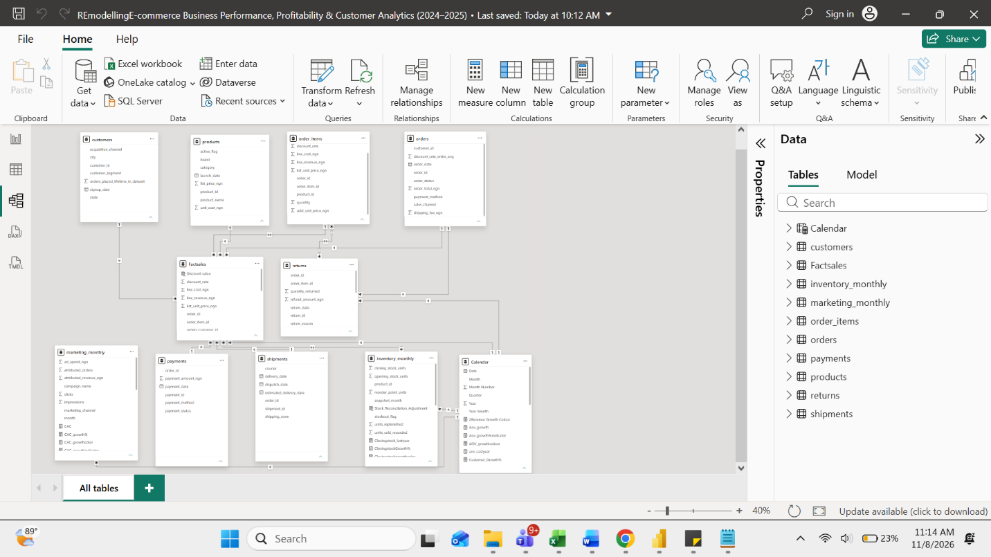

Fact tables
Fact tables contain the measurable business activities used in the analysis.
Fact table | Description | Key measures
FactSales | Records individual sales transactions | Revenue, profit, quantity sold, orders
FactReturns | Records product return transactions | Return quantity, return rate
FactInventory | Records monthly product inventory movements | Opening stock, replenishment, units sold, closing stock
FactMarketing | Records marketing expenditure | Marketing spend, acquisition cost
Dimension tables
Dimension tables provide descriptive attributes used to analyse the fact tables.
Dimension table | Description
DimDate | Calendar information, including date, month, quarter and year
DimProduct | Product names, categories and brands
DimCustomer | Customer details and customer segments
DimChannel | Marketing and acquisition channels
DimShipment | Courier services and shipping location
Relationships and model configuration
The fact and dimension tables were connected using primary and foreign keys.
The model primarily uses one-to-many (1:*) relationships, with dimension tables positioned on the one side and fact tables on the many side.
The relationship configuration uses single-direction filtering to maintain predictable filter propagation and minimise ambiguity.

4. ANALYTICAL METHODOLOGY AND KPI DEFINITIONS
4.1 Analytical Approach
The project employed descriptive analytics to examine historical business performance and identify trends, patterns and exceptions.
Power Query was used for data transformation, DAX for KPI calculations and Power BI for interactive visualization.
4.2 Key Performance Indicators
KPI | Definition
Total Revenue | total sales value
Revenue Growth (%) | Percentage change in revenue
Average Order Value | Average revenue per order
Marketing Spend | Total marketing expenditure
Customer Acquisition Cost | Marketing expenditure per new customer acquired
Return Rate | Proportion of sales or orders returned
Stock Replenishment Rate | Rate of inventory replenishment

5. DASHBOARD ANALYSIS AND KEY FINDINGS
5.1 Executive Performance Analysis
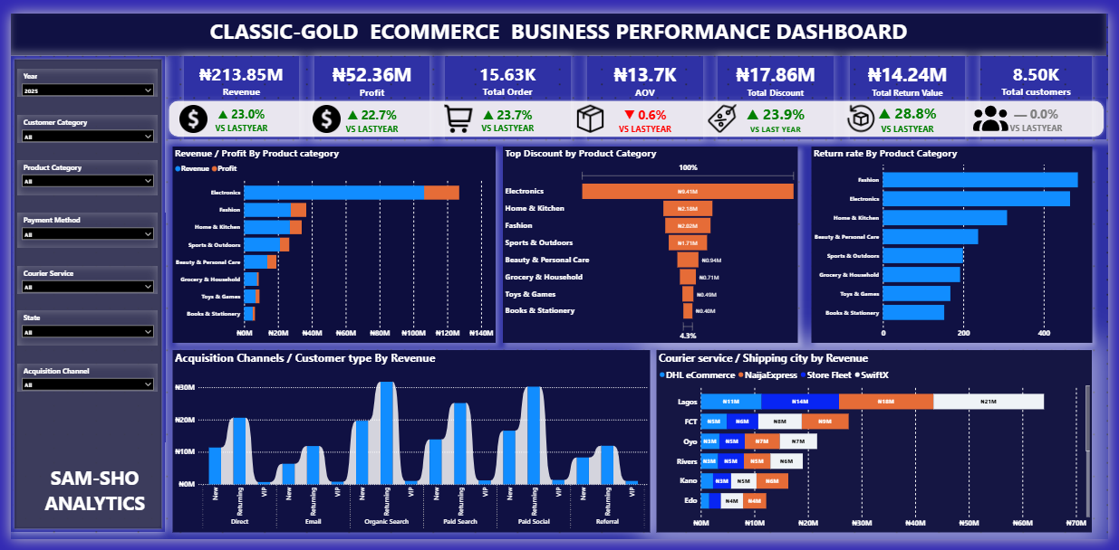
Key observations:
- Positive Business Growth Driven by Repeat Purchases: Revenue, profit and order volumes increased year-on-year, supported by returning customers who contributed 64% of total revenue. However, declining AOV indicates that growth is largely volume-driven, with lower customer spending per transaction.
- Improved Marketing Performance Amid Rising Acquisition Costs: Advertising engagement and ROAS improved, with Paid Search and Paid Social leading revenue contributions. However, rising CAC and declining conversion rates suggest that increased advertising expenditure is not translating proportionately into customer acquisitions and completed purchases.
- Inventory Improvement Offset by Rising Product Returns: Stock replenishment improved marginally to 69.65%, while product returns increased by 28.8% year-on-year. Electronics and Fashion recorded the highest return rates, with unclear product descriptions and fulfilment/delivery damage emerging as key areas of concern.

Business interpretation:
The business is experiencing growth, but the quality and sustainability of that growth require attention. Revenue expansion is supported by repeat purchases and increased order volumes, while rising acquisition costs, declining conversion rates and increasing product returns present potential threats to future profitability.
Management should therefore focus not only on generating more sales but also on improving the value of each transaction, acquiring customers more efficiently, retaining existing customers and reducing avoidable product returns.
5.2 Sales Performance Analysis
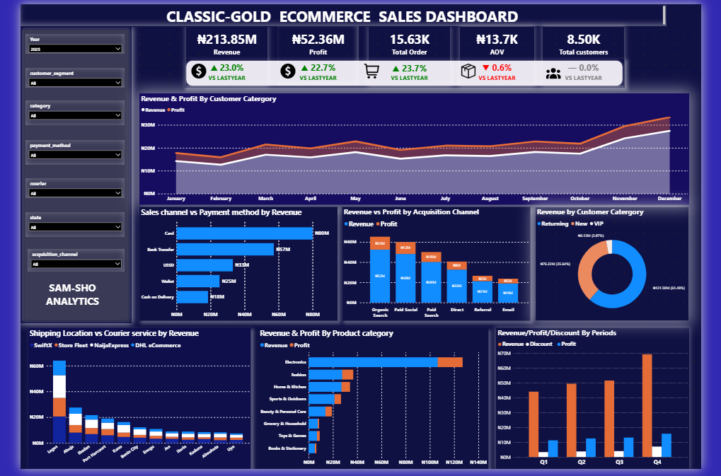
Key observations:
Sales Performance and Revenue Growth
- Positive revenue and profitability growth: Revenue, profit and order volume increased year-on-year, despite a relatively stable customer base, indicating increased purchasing activity among existing customers.
- Strong contribution from returning customers: Returning customers generated 64% of total revenue, highlighting the importance of customer retention to overall business performance.
- Declining Average Order Value (AOV): Despite increased order volumes, AOV declined, suggesting that customers are placing more orders but spending less per transaction.
Business interpretation:
- Positive revenue and profitability growth: The increase in revenue, profit and order volume indicates that the business is expanding its sales activity and generating improved financial returns. However, growth appears to be driven more by transaction frequency than by an increase in customer spending.
- Strong contribution from returning customers: The 64% revenue contribution from returning customers suggests that the existing customer base is a major source of business revenue. This creates an opportunity to strengthen customer loyalty, repeat purchases and long-term customer value. However, it also makes customer retention critical to sustaining revenue.
- Declining Average Order Value (AOV): Customers are spending less per transaction despite placing more orders. This may indicate smaller basket sizes, increased discounting or a shift towards lower-priced products, potentially limiting revenue growth per customer.

5.3 Marketing Performance Analysis
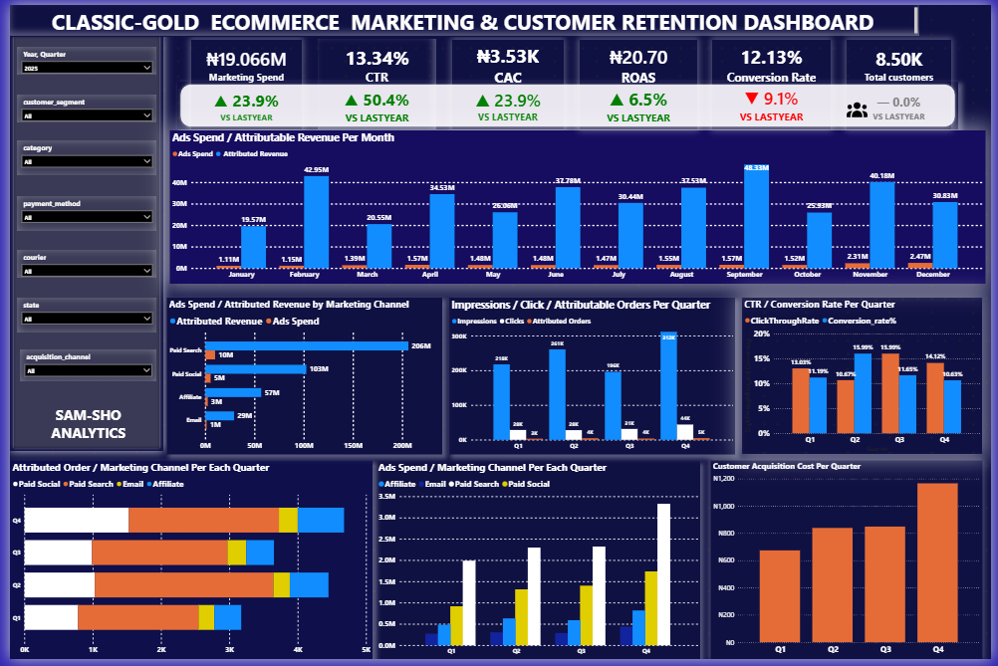
Key observations:

- Improved advertising engagement and returns: CTR and ROAS increased, with Paid Search and Paid Social emerging as the leading contributors to advertising-attributed revenue.
- Rising customer acquisition costs: CAC increased, indicating that acquiring new customers is becoming more expensive.
- Weakening conversion and transaction value: Declining conversion rates and AOV suggest that increased advertising engagement and expenditure are not translating proportionately into completed purchases and higher transaction values.

Business interpretation:

- Improved advertising engagement and returns: Increased CTR and ROAS suggest that advertising campaigns are attracting more attention and generating better attributed revenue. Paid Search and Paid Social are important acquisition and revenue-generating channels that management should continue to monitor and optimize.
- Rising customer acquisition costs: The increase in CAC suggests that the business is spending more to acquire each new customer. If this trend continues without a corresponding improvement in customer lifetime value, the cost of acquiring customers could gradually erode profitability.
- Weakening conversion and transaction value: The decline in conversion rates and AOV suggests a gap between attracting potential customers and converting them into valuable purchases. This may point to issues with traffic quality, pricing, product appeal, checkout experience or promotional effectiveness.

5.4 Inventory Performance Analysis

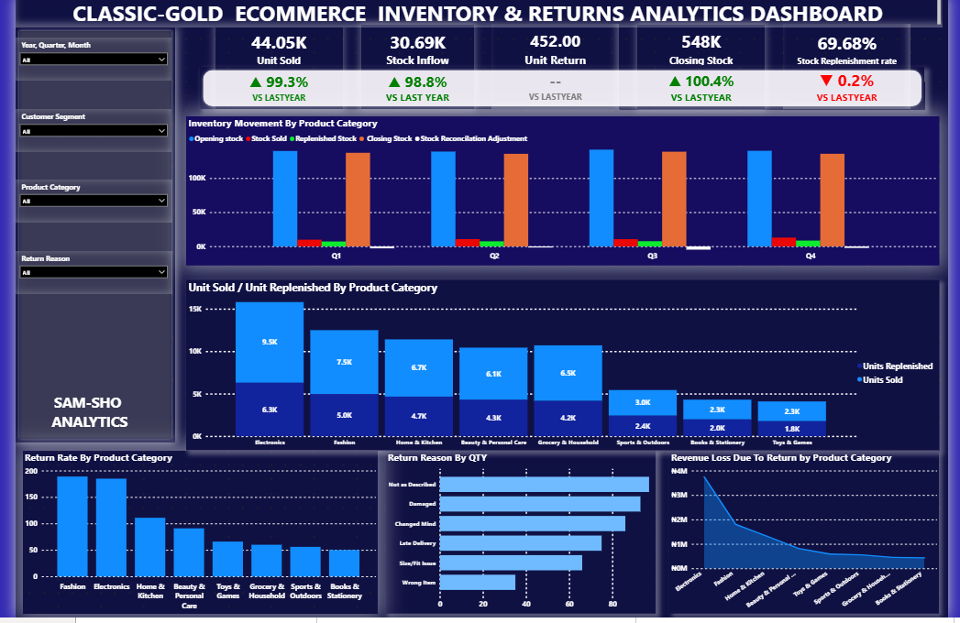
Key observations:
- Marginal improvement in stock replenishment: The replenishment rate increased slightly to 69.65%, representing a 0.01 percentage-point improvement over 2024.
- Significant increase in product returns: Product returns increased by 28.8% year-on-year, with unclear product descriptions and product damage during fulfilment or delivery emerging as key return reasons.
- High-return product categories: Electronics and Fashion recorded the highest return rates, highlighting potential weaknesses in product information accuracy, quality assurance and delivery handling.

Business interpretation:

- Marginal improvement in stock replenishment: The slight increase in replenishment rate indicates limited progress in restoring inventory levels. However, the rate remains an area requiring attention, as inadequate replenishment could result in stock shortages, missed sales opportunities and inconsistent product availability.
- Significant increase in product returns: The 28.8% increase in returns suggests growing product fulfilment and customer satisfaction concerns. Returns create additional costs through reverse logistics, handling, potential product damage and inventory write-downs, while also potentially weakening customer confidence.
- High-return product categories: The high return rates in Electronics and Fashion suggest that these categories require closer management attention. Differences between product descriptions and actual products, product quality issues and delivery damage may be contributing to customer dissatisfaction and avoidable return costs.

6. BUSINESS RECOMMENDATIONS
Based on the findings, the following actions are recommended:
Business Area | Recommendation | Expected Benefit
Sales | Develop strategies to increase Average Order Value (AOV), such as product bundling, cross-selling, upselling and targeted promotions. Strengthen customer retention through loyalty programmes and personalized offers to returning customers. | Increase average transaction value, maximise revenue from existing customers and sustain revenue growth through repeat purchases.
Marketing | Review advertising performance across Paid Search and Paid Social to identify campaigns generating quality traffic and profitable conversions. Optimize advertising budgets towards effective channels, monitor CAC against customer lifetime value (CLV), and investigate factors contributing to declining conversion rates. | Reduce customer acquisition costs, improve marketing efficiency, increase conversion rates and achieve more sustainable returns on advertising expenditure.
Inventory | Strengthen inventory replenishment planning using sales trends and product demand forecasts. Review return patterns, particularly in Electronics and Fashion, improve product descriptions and product quality checks, and enforce appropriate packaging and delivery handling procedures. | Improve product availability, minimise stock shortages, reduce avoidable product returns and associated costs, and enhance customer satisfaction.
Management | Establish a periodic business performance review covering sales, profitability, customer retention, marketing efficiency and inventory returns. Assign responsibility for monitoring key performance indicators (KPIs), investigating unfavourable trends and tracking the implementation of corrective actions. | Improve management oversight, promote accountability, facilitate timely decision-making and ensure that business growth translates into sustainable profitability and operational efficiency.
Overall recommendation: Management should adopt a performance-driven approach that balances revenue growth with customer value, marketing efficiency and inventory effectiveness. This will help ensure that increased sales activity translates into sustainable business performance rather than higher operating costs.

7. ANALYSIS LIMITATIONS AND ASSUMPTIONS
7.1 Analysis Limitations
The analysis is subject to the following limitations:
- Synthetic Dataset: The dataset is synthetically generated to simulate real-life e-commerce transactions and may not fully reflect the complexities of actual business operations.
- Data Accuracy and Completeness: The reliability of the findings depends on the accuracy, consistency and completeness of the available dataset.
- Limited Business Context: The analysis is based primarily on available transactional, customer, marketing and inventory data. External factors such as competitor activities, economic conditions and changes in customer preferences were not independently assessed.
- Limited Causal Evidence: Observed relationships and performance trends indicate possible business drivers but do not independently establish cause-and-effect relationships.
- Predictive Limitations: Historical performance patterns may provide useful indications of future trends but do not guarantee future business outcomes.
7.2 Analytical Assumptions
The following assumptions were applied in conducting the analysis:
- Revenue and Profitability: Revenue and profit figures are assumed to have been consistently recorded, with the profit measure reflecting the cost components included in the dataset.
- Customer Classification: Customers classified as new or returning are identified based on their recorded transaction history within the available dataset.
- Customer Acquisition Cost (CAC): Marketing expenditure is assumed to represent the relevant acquisition cost for the period, while newly acquired customers are used as the basis for calculating CAC.
- Return Rate: Product return rates are calculated using recorded returned quantities or transactions against the corresponding sales volume, depending on the KPI definition.
- Inventory Replenishment: Replenishment performance is assessed using recorded replenishment quantities against the defined inventory replenishment requirement.
- Period Comparison: Year-on-year comparisons assume that the periods analysed are sufficiently comparable in terms of reporting coverage and KPI definitions.

8. CONCLUSION
This project demonstrates how business intelligence can integrate sales, marketing and inventory information into a unified reporting solution.
The analysis provides management with visibility into business performance, highlights potential areas requiring attention and translates historical data into actionable business recommendations.
The resulting Power BI dashboard serves as an interactive decision-support tool for monitoring business performance and supporting evidence-based management decisions.

9. PROJECT DELIVERABLES
- Interactive Power BI dashboard: https://77qe7rr.s.gy/ecommerce_dashboard_project
- Project dataset: [Insert link]
- Power BI project file (.pbix): [Insert link]
- Supporting documentation: [Insert link]
- GitHub repository: [Insert link]

